ER DIAGRAM:

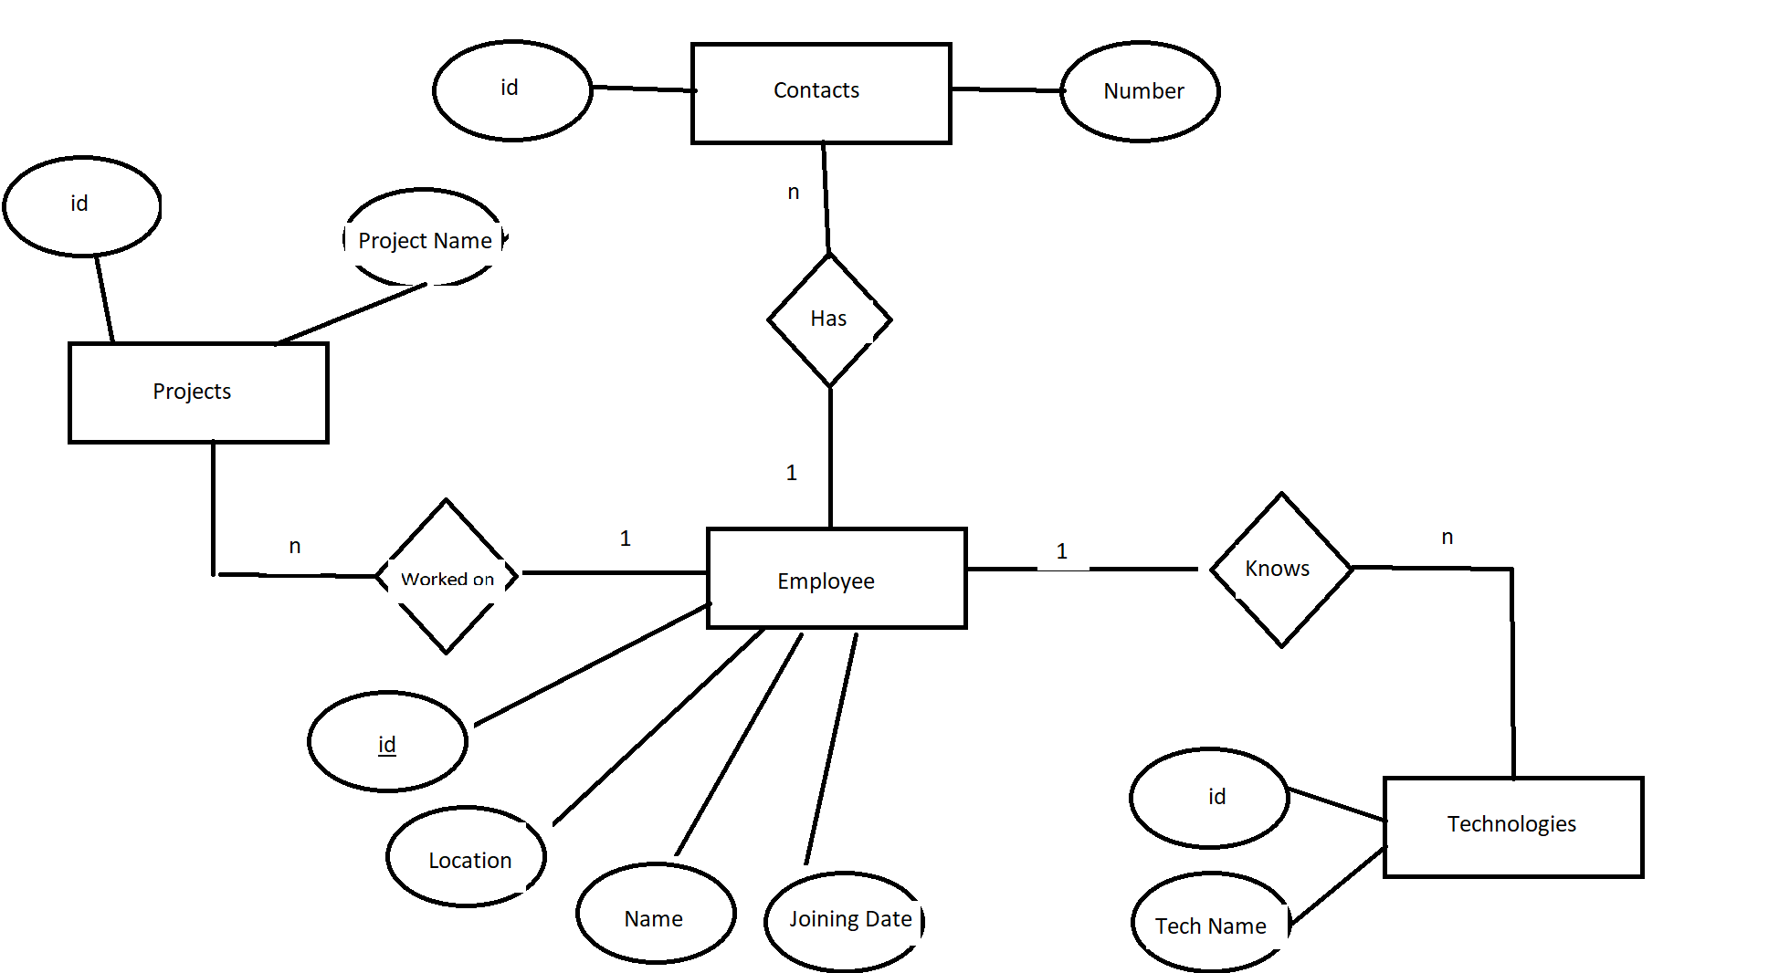

1NF

As per the rule of first normal form, an attribute (column) of a table cannot hold multiple values. It should hold only atomic values.

All the tables in the above schema have atomic attributes. Hence it is in 1NF

2NF

A table is said to be in 2NF if both the following conditions hold:

* Table is in 1NF (First normal form)
* No non-prime attribute is dependent on the proper subset of any candidate key of table.

Consider the employee table. There is only one candidate key: id(employee_id). Hence the proper subsets of candidate key is an empty set. Therefore there are no non-prime attributes which are dependent on the proper subset of candidate key.

3NF

A table design is said to be in 3NF if both the following conditions hold:

* Table must be in 2NF
* [Transitive functional dependency](https://beginnersbook.com/2015/04/transitive-dependency-in-dbms/) of non-prime attribute on any super key should be removed.

The employee table has the following dependencies:

Id 🡪 name

Id 🡪 location(city)

Id 🡪 Date of joining.

Hence the table is in 3NF as there are no Transitive dependencies.

NOTE: If the employee table had an attribute like ‘zip_code’ then there would have been a transitive dependency as :

zip_code 🡪 location(city)

Then the table would not be in 3NF.

BCNF

. A table complies with BCNF if it is in 3NF and for every [functional dependency](https://beginnersbook.com/2015/04/functional-dependency-in-dbms/) X->Y, X should be the super key of the table.

Cleary, the employee table is in BCNF.